DO NOT WRITE ON TEST


PROJECT MANAGEMENT CONCEPTS
~OPEN EVENT~
(593)
STATE 2021

TOTAL POINTS ____________100 Points

Test Time: 60 minutes

Identify the letter of the choice that best completes the statement or answers the question.
- Client interest is usually at its lowest during the _____ phase.
  - planning
  - organizing
  - execution
  - termination

- A _____ organization is defined as one in which there is dual, or multiple, managerial accountability and responsibility.
  - project
  - matrix
  - functional
  - divisional

- All of the following are considered external project stakeholders except _____.
  - employees
  - customers
  - suppliers
  - creditors

- Which of the following best describes a matrix that matches internal factors to external factors in order to identify relevant strategic options that an organization can pursue?
  - SWOT
  - EMU
  - APF
  - TOWS

- Which of the following is an effective mitigation strategy to consider when developing a risk response plan for threats?
  - avoid
  - exploit
  - share
  - accept

- What is the discounted payback period of an investment based on an initial investment of $2,324,000 that is expected to generate $600,000 per year for six years with an 11% discount rate?
  - 4.19 years
  - 5.33 years
  - 6.23 years
  - 7.47 years

- In most organizations, the ______ defines the mission, vision, values and strategy.
  - portfolio manager
  - contractor
  - project manager
  - executive leadership
- Which of the following leadership styles is being displayed when a project manager turns things over to team members and only monitors the work at a high level?
  - autocratic
  - directing
  - democratic
  - laissez-faire

- A _____ is any product, service, or result that must be completed to finish a project.
  - deliverable
  - constraint
  - opportunity
  - program

- In the critical path method, the latest possible point in time when the uncompleted portions of a scheduled activity can start based on the project completion date, the schedule network logic, and any schedule constraints is known as the _____ date.
  - early start
  - early finish
  - late start
  - late finish

- Which of the following describes the knowledge gained during a project which shows how project events were addressed or should be addressed in the future with the intent of improving future performance?
  - milestone
  - baseline
  - lessons learned
  - assumption

- What is the total calculated number of potential communication channels for a project with 20 stakeholders?
  - 20
  - 85
  - 200
  - 190

- A project with a current estimate at completion (EAC) of $60,000 and a budget at completion (BAC) of $50,000 has a variance at completion (VAC) of _____.
  - -$10,000
  - $10,000
  - 1.2
  - .83

- A project is expected to result in $1 million in five years. The current interest rate is 5%. What is the present value (PV) of the project?
  - $1,050,000
  - $200,000
  - $952,381
  - $783,526

- A project manager purchased a new laptop for $2,500. Assuming it can be scrapped at the end of a three-year life for $250, what is the annual depreciation using straight line depreciation?
  - $250
  - $750
  - $500
  - $833

- Which of the following techniques would be the best solution for a project manager seeking expert opinions on technical issues?
  - Monte Carlo
  - critical path
  - Delphi
  - lessons learned

- During which stage of a product’s life cycle are production and marketing costs high and sales volume low?
  - introduction
  - growth
  - maturity
  - decline

- Which of the following plans describe how an organization’s guidelines, policies, and procedures will be implemented to achieve the quality objectives?
  - requirements management
  - contingency
  - cost management
  - quality management

- Which of the following describes a risk response strategy where the project team acts to eliminate the threat and/or protect the project team from its impact?
  - risk acceptance
  - risk exploiting
  - risk avoidance
  - risk enhancement

- Which of the following is a component of the resource management plan that describes when and how team members will be acquired and how long they will be needed?
  - staff management
  - stakeholder engagement
  - scope management
  - risk management plan

- A project manager delays ‘Activity 1’ by two days without delaying its successor, ‘Activity 2’. Delaying ‘Activity 2’ will delay the project by four days without delaying the overall project finish date. Which of the following statements is correct in this scenario?
  - The free float is three days and the total float is zero days.
  - The free float is two days and the total float is four days.
  - The free float is four days and the total float is two days.
  - The free float is two days and the total float is six days.

- Which of the following is not typically classified as a selling or administrative cost?
  - rent
  - utilities
  - advertising
  - income taxes

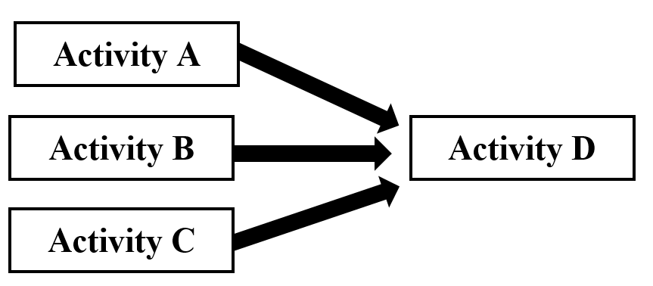
- Based on the depicted diagram, _____.

  - Activities A, B and C must be complete before Activity D can begin
  - Activities A, B, C, and D can all start at the same time
  - Activity A must be complete before Activity B can begin
  - Activity D can start at the same time as Activity A

- Which of the following describes the length of time expected to complete an activity assuming that its development proceeds based on the shortest estimated time period?
  - most likely
  - least likely
  - optimistic
  - pessimistic

- Which of the following best describes Douglas McGregor’s Theory X in regard to management beliefs towards workers?
  - The average worker seeks the opportunity for personal improvement and self-respect.
  - The average worker wants to be active and finds the physical and mental effort on the job to be satisfying.
  - The average worker will produce self-direction without coercion or control.
  - The average worker lacks ambition and desires security above everything else.

- Based on the motivation-hygiene theory, which of the following are considered hygiene factors?
  - achievement
  - working conditions
  - advancement
  - all of the above

- Which motivational theory is based on the concept that human beings have basic needs that must be met before they can advance to the next level of needs?
  - Maslow’s Hierarchy of Needs Theory
  - ERG Theory
  - McClelland’s Theory of Needs
  - Vroom’s Expectancy Theory

- Which of the following describes the point in the distribution where 50% of the results are above the value, and 50% of the results are below the value?
  - outlier
  - mean
  - median
  - mode

- Which of the following would not be a valid reason for crashing a project?
  - when there are no repercussions for delivering the project late
  - when the team is needed on other work
  - when meeting a fixed deadline
  - when part of the project jeopardizes progress

- A _____ logical relationship is one in which a successor activity cannot start until a predecessor activity has started.
  - start-to-finish
  - finish-to-start
  - start-to-start
  - finish-to-finish

- _____ is the work defined at the lowest level of the work breakdown structure for which cost and duration are estimated and managed.
  - Budget at completion
  - Lag
  - Baseline
  - Work package

- Which of the following describes earned value?
  - the actual value of the work completed so far at a specific date
  - the approved value of the work to be completed in a given time
  - the total amount spent for the actual work completed to date
  - the expected cost to finish all the remaining project work

- A project reporting a schedule performance index (SPI) ratio of less than one (SPI < 1) is _____.
  - ahead of schedule
  - behind schedule
  - under budget
  - over budget

- What does a cost performance index (CPI) ratio greater than one (CPI > 1) indicate?
  - The project is ahead of schedule.
  - The project is behind schedule.
  - The project is over budget.
  - The project is under budget.

- Which of the following describes the four major phases of a standard project?
  - initiation – planning – execution – closing
  - research – initiation – planning – execution
  - planning – execution – evaluation – closing
  - proposal – implementation – assessment – termination

- Which group is responsible for providing raw materials or resources needed by the project team to complete the project?
  - top managers
  - functional managers
  - suppliers
  - owners

- _____ are temporary in nature and have a definite beginning and ending date.
  - Projects
  - Portfolios
  - Programs
  - All of the above

- Which of the following roles may a project manager fulfill during negotiations?
  - negotiator
  - mediator
  - arbitrator
  - all of the above

- What is the probability of failure for a project with a maturity risk of 0.4, a complexity risk of 0.5, and a dependency risk of 0.6?
  - 0.3
  - 0.4
  - 0.5
  - 0.6

- During which stage of team development does the team leader create structure and set the tone for future cooperation and positive team attitudes?
  - forming
  - storming
  - norming
  - performing

- Based on the activity box shown below, which number reflects the late start date?
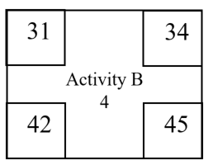

  - 31
  - 34
  - 42
  - 45

- Which of the following identifies risks based on categories such as strategic, finance, operational, external, and project management in a hierarchical format?
  - risk register
  - decision tree
  - PERT diagram
  - risk breakdown structure

- All of the following are included in the project cost management process except _____.
  - plan cost management
  - estimate activity durations
  - estimate costs
  - determine budget
- The lessons learned register, project management plan updates, and organizational process assets updates are outputs in the ____ process stage.
  - direct and manage project work
  - manage project knowledge
  - monitor and control project work
  - perform integrated change control

- Which of the following activities are not included in a project kick-off meeting?
  - lessons learned
  - roles and responsibilities
  - timelines
  - communication and meeting plans

- _____ is the process of reviewing all change requests; approving changes and managing changes to deliverables, organizational process assets, project documents, and the project plan; and communicating their disposition.
  - Perform project monitoring
  - Perform quality control
  - Perform integrated change control
  - Perform quality assurance

- Which of the following is generally not included in quality control activities?
  - inspection
  - testing
  - deliverable peer reviews
  - project audit

- Which of the following measures is used to determine whether a project is ahead, on, or behind schedule?
  - schedule variance
  - three-point estimating
  - schedule performance index
  - s-curve analysis

- _____ are typically not captured in project meeting minutes.
  - Actions or tasks
  - Personal observations
  - Calendar or due dates
  - Participant names

- A project communications matrix includes all of the following information except _____.
  - what
  - where
  - who
  - why

